Script 2

1. Get a list of all instances.

2. Stop all running instances at specified times

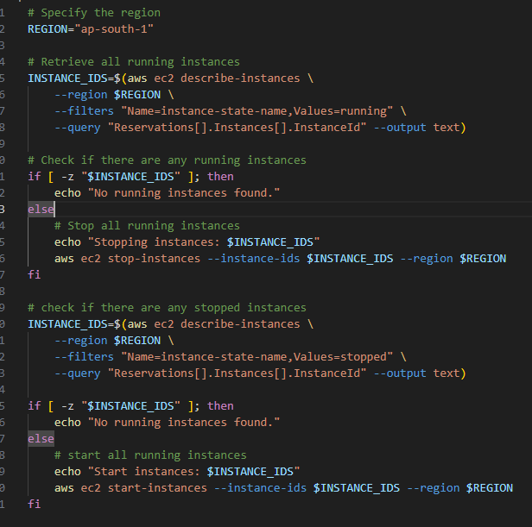

Output:

acer@DESKTOP-C3JJHM8 MINGW64 /f/New folder

$ ./script-2.sh

Stopping instances: i-0eee5b9dffe518e91 i-0951244bd05af761b i-08763e5b22529625a i-03088fc117874d737 i-0c9fc5c2225344aa0 i-08782c7dd0f6fe3b2 i-0b472d08f8638d3eb i-050ba8ec635975ad3 i-032859505e006a61f i-057ced34981792b7c i-00e4eea69e8c0133b i-0113d3f74431c3e88 i-0ed9e1e0441873ca1

{

"StoppingInstances": [

{

"CurrentState": {

"Code": 64,

"Name": "stopping"

},

"InstanceId": "i-00e4eea69e8c0133b",

"PreviousState": {

"Code": 16,

"Name": "running"

}

},

{

"CurrentState": {

"Code": 64,

"Name": "stopping"

},

"InstanceId": "i-0113d3f74431c3e88",

"PreviousState": {

"Code": 16,

"Name": "running"

}

},

{

"CurrentState": {

"Code": 64,

"Name": "stopping"

},

"InstanceId": "i-0ed9e1e0441873ca1",

"PreviousState": {

"Code": 16,

"Name": "running"

}

},

{

"CurrentState": {

"Code": 64,

"Name": "stopping"

},

"InstanceId": "i-0b472d08f8638d3eb",

"PreviousState": {

"Code": 16,

"Name": "running"

}

},

{

"CurrentState": {

"Code": 64,

"Name": "stopping"

},

"InstanceId": "i-0951244bd05af761b",

"PreviousState": {

"Code": 16,

"Name": "running"

}

},

{

"CurrentState": {

"Code": 64,

"Name": "stopping"

},

"InstanceId": "i-032859505e006a61f",

"PreviousState": {

"Code": 16,

"Name": "running"

}

},

{

"CurrentState": {

"Code": 64,

"Name": "stopping"

},

"InstanceId": "i-057ced34981792b7c",

"PreviousState": {

"Code": 16,

"Name": "running"

}

},

{

"CurrentState": {

"Code": 64,

"Name": "stopping"

},

"InstanceId": "i-08782c7dd0f6fe3b2",

"PreviousState": {

"Code": 16,

"Name": "running"

}

},

{

"CurrentState": {

"Code": 64,

"Name": "stopping"

},

"InstanceId": "i-0c9fc5c2225344aa0",

"PreviousState": {

"Code": 16,

"Name": "running"

}

},

{

"CurrentState": {

"Code": 64,

"Name": "stopping"

},

"InstanceId": "i-0eee5b9dffe518e91",

"PreviousState": {

"Code": 16,

"Name": "running"

}

},

{

"CurrentState": {

"Code": 64,

"Name": "stopping"

},

"InstanceId": "i-08763e5b22529625a",

"PreviousState": {

"Code": 16,

"Name": "running"

}

},

{

"CurrentState": {

"Code": 64,

"Name": "stopping"

},

"InstanceId": "i-03088fc117874d737",

"PreviousState": {

"Code": 16,

"Name": "running"

}

},

{

"CurrentState": {

"Code": 64,

"Name": "stopping"

},

"InstanceId": "i-050ba8ec635975ad3",

"PreviousState": {

"Code": 16,

"Name": "running"

}

}

]

}

Start instances: i-0eee5b9dffe518e91 i-030709a52d937b786 i-0951244bd05af761b i-08763e5b22529625a i-03088fc117874d737 i-0c9fc5c2225344aa0 i-08782c7dd0f6fe3b2 i-0b472d08f8638d3eb i-050ba8ec635975ad3 i-032859505e006a61f i-057ced34981792b7c i-00e4eea69e8c0133b i-0113d3f74431c3e88 i-0ed9e1e0441873ca1

{

"StartingInstances": [

{

"CurrentState": {

"Code": 0,

"Name": "pending"

},

"InstanceId": "i-00e4eea69e8c0133b",

"PreviousState": {

"Code": 80,

"Name": "stopped"

}

},

{

"CurrentState": {

"Code": 0,

"Name": "pending"

},

"InstanceId": "i-0113d3f74431c3e88",

"PreviousState": {

"Code": 80,

"Name": "stopped"

}

},

{

"CurrentState": {

"Code": 0,

"Name": "pending"

},

"InstanceId": "i-0ed9e1e0441873ca1",

"PreviousState": {

"Code": 80,

"Name": "stopped"

}

},

{

"CurrentState": {

"Code": 0,

"Name": "pending"

},

"InstanceId": "i-0b472d08f8638d3eb",

"PreviousState": {

"Code": 80,

"Name": "stopped"

}